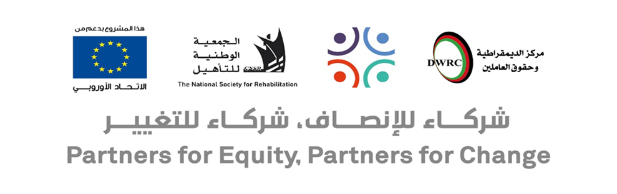
Call for proposals
Grants to third parties to enable grassroots CSOs to engage in advocacy at local level

Through the project “Partners for Equity, Partners for Change” funded by the European Union, the Democracy and Workers’ Rights Center in Palestine, in partnership with the National Society for Rehabilitation – Gaza Strip, is launching a call for proposals for providing three grants to grassroots CSOs (minimum 30,000 EUR and maximum 40,000 EUR) to undertake local advocacy activities in the West Bank and Gaza Strip. The specific objective of the sub-grant is to enhance the capacity of CSOs to engage in joint advocacy for advancing the labor & socio-economic rights of women and persons with disabilities at the local level, including the rights of women with disabilities.
Information session about the call: Wednesday July 15, 2026 at 11:00 a.m. in Gaza, Ramallah and simultaneously online
Registered grassroots CSOs operating in the West Bank or Gaza Strip that are members of the National Coalition “My Right” for Advocating for Women’s Economic Rights and their Right to Decent Work and one of its local committees are invited to submit a project to this call for proposals.
The guidelines for the call for proposals and application forms can be requested by email to smallgrants@dwrc.org or downloaded from DWRC website: www.dwrc.org. The proposal submission deadline is 30/07/2026
Registration for attending information sessions is open until 12/07/2026 at the link in the post

